California State University Fullerton

CPSC 462



Object Oriented Software Design

Domain Model

for the

1. Update placeholder with your project’s title being careful not to delete the (potentially hidden) bookmark. If you did it right, the document’s footer will be updated too
2. Delete this bubble

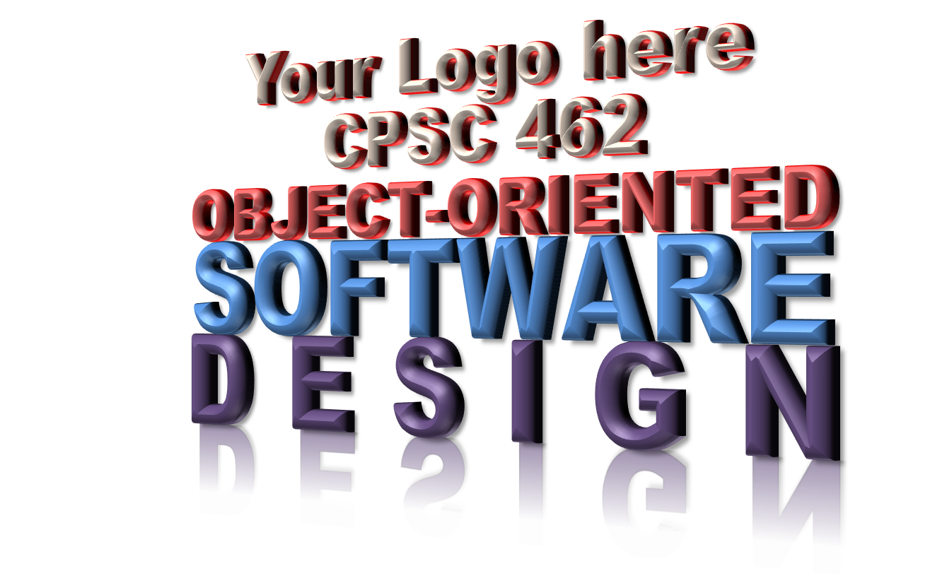

<Your Project Title here>

System

|  |  |  |
| --- | --- | --- |
| **<Student Name 1 here>** | **<Student Name 2 here>** | **<Student Name 3 here>** |
| <Title / Roll within project> | <Title / Roll within project > | <Title / Roll within project > |
| <[Email1@csu.fullerton.edu](mailto:Email1@csu.fullerton.edu)> | <[Email2@csu.fullerton.edu](mailto:Email2@csu.fullerton.edu)> | <[Email3@csu.fullerton.edu](mailto:Email3@csu.fullerton.edu)> |

Revision History:

| Version | Date | Summary of Changes | Author |
| --- | --- | --- | --- |
| 1.0 | <date of release> | * Initial Release | <Name 1>  <Name 2>  … |
|  |  |  |  |
|  |  |  |  |
|  |  |  |  |

Table of Contents

1 Domain’s Major Concepts 1

1.1 <Term or Concept 1> 1

1.2 <Term or Concept 2> 1

1.3 <Term or Concept X> 1

2 Domain Model Diagram 2

NOTE TO STUDENTS:

1. See Larman §1.5 A Short Example, Chapter 9 in entirety, §11.6 Guideline: Should We Update the Domain Mode, 26.3 “Analysis” Discoveries During Design: Domain Model, Chapter 32, Domain Model Refinement
2. It is very important that terms and concepts described and/or shown in this Domain Model are also in your Glossary. The Terms or concepts in the subparagraphs below should be shown on the diagram.
3. Remember, the most important thing on the diagram are the lines between the Concepts (rectangles), but the concepts are important too
4. Do not show Actors – Actors are external to the system
5. Delete this NOTE before you deliver

# Domain’s Major Concepts

## <Term or Concept 1>

…

## <Term or Concept 2>

…

## <Term or Concept X>

…

# Domain Model Diagram

<Insert Domain Model Diagram here>